**PROJECT REPORT**

**1. INTRODUCTION**

* 1. **OVERVIEW**

• The term digital marketing refers to the use of digital Channels to market products and services to consumers this type of marketing involves the use of websites, mobile Devices, social media, search engines, and other similar Channels. Digital marketing became popular with the advent Of the internet in the 1990s.

• Smartphones and other digital devices now make it easier For companies to market themselves and their products and Services to consumers. Studies show that people prefer Using their phones to go online. In fact, according to a Pew Research Center study, over 75% of American adults Typically make shopping purchases using their phones.

* 1. **PURPOSE**

• Marketing involves a business’s different aspects, such as Product development advertising, sales, and distribution Methods. The key purpose of marketing is to get people Interested in the products or services of a company. This Happens through market analysis, research and Contemplating the interest of a business’s ideal customers and attracting them through messaging which would be educational and helpful to a business’s target group. In turn, this would also help businesses convert a higher number of leads into customers

• Though it may seem unbelievable, modern marketing began Back in the 1950s. It was the time when people started to Use platforms and channels beyond print media to endorse Their products. Then, as television and soon, the internet entered households, the marketers were able to conduct entire campaigns spanning multiple platforms. This eventually increased the importance of marketers to fine tune how businesses sell products or services to customers while optimizing their success.

•In the current times, there is a myriad of platforms where Marketers can carry out sales and marketing campaigns. Let’s take a look at the types of marketing

**PROBLEM DEFINITION & DESIGN THINKING**

**2.1 Empathy Map**

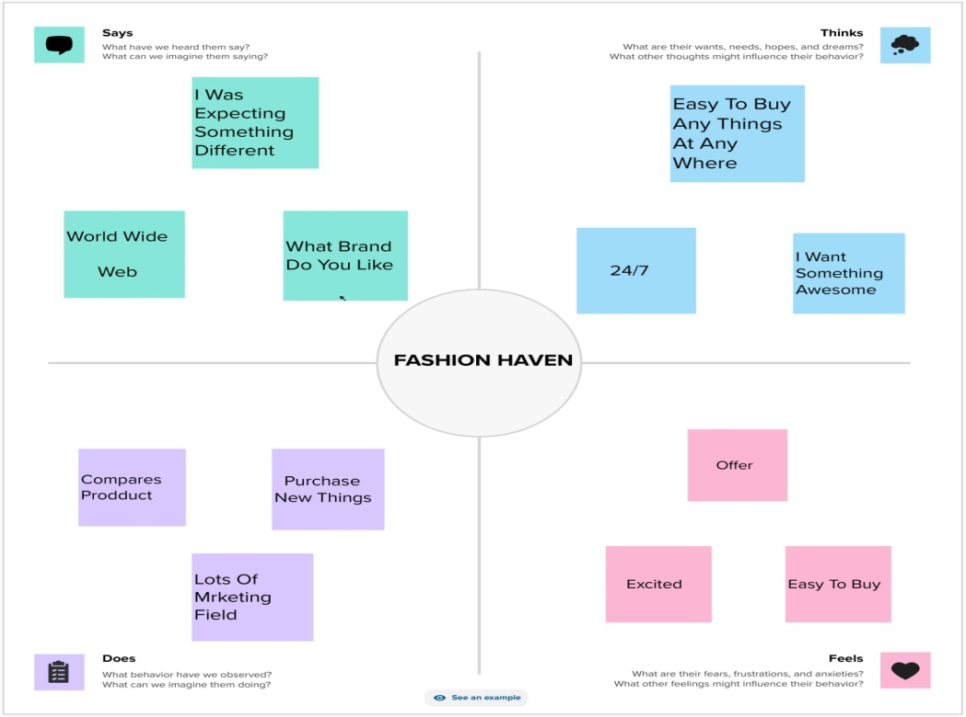

**2.2 Ideation & Brainstorming**

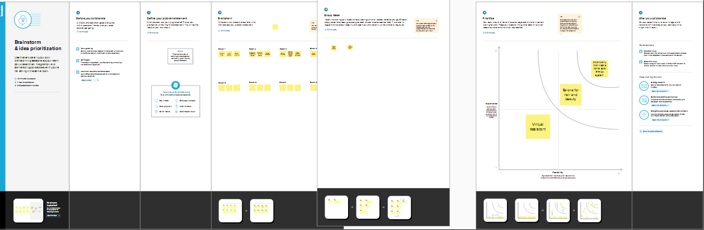

**3. RESULT**

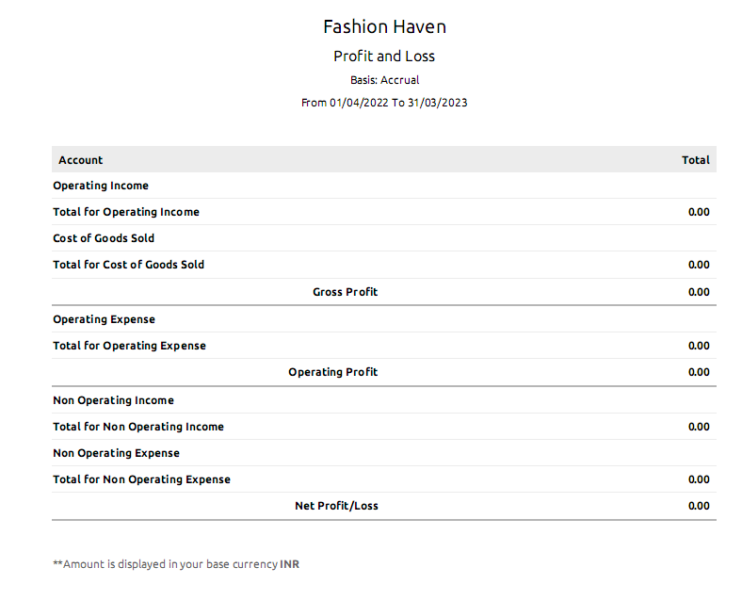

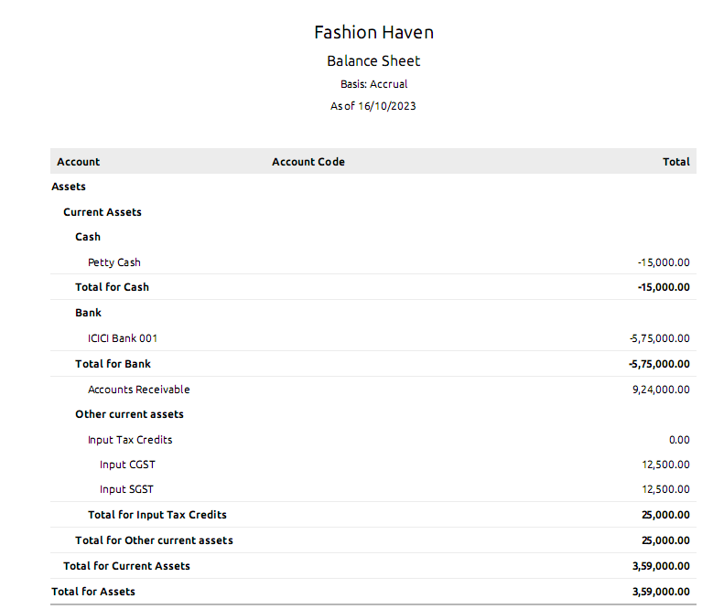

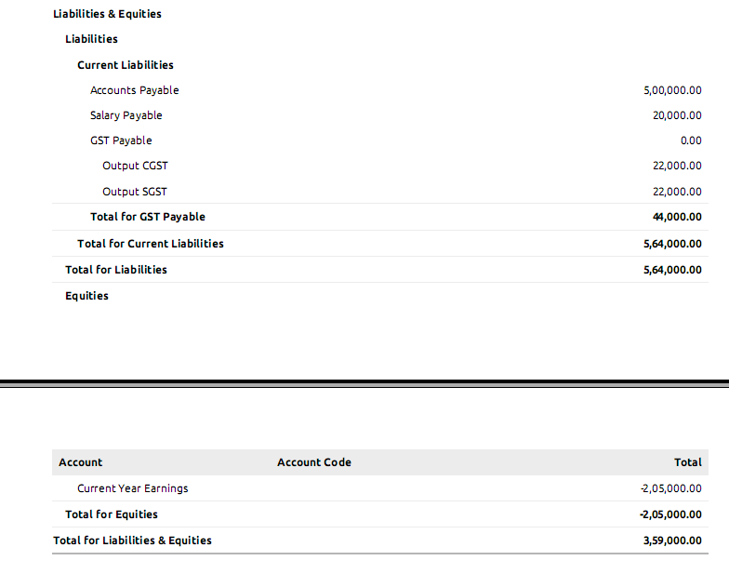

**4. ADVANTAGES & DISADVANTAGES**

**Advantages:**

1. **Online marketing has a global reach**

While traditional offline marketing is limited by geography, online marketing is not. This opens ups opportunities for easily and affordably creating global marketing campaigns. Even a small business can reach an international audience by opening an e-store. So, with a little innovativeness, businesses can gain global visibility and reach.

**2. Better local reach**

Online marketing also improves local visibility, which is particularly crucial important if your business depends on customers in your locality. You can bring more customers to your doors with local SEO and locally targeted ads. This would cost you just a fraction of the cost and effort required for offline marketing. Further, you can also focus on the local links by targeting colleges or universities, city-specific sites and directories, and local news. For this, you can check with the firms or companies that can help you in creating backlinks that can help you to improve your local reach and target the local audience.

**3. Brand Development**

Brand development developing a brand involves taking different kinds of efforts to make its customers consider it trustable and reliable. Online marketing simplifies this as you can carry out direct campaigning in a personalized manner to engage customers and give them an experience of your brand. Conveying your brand’s value and unique selling proposition positively influences them.

**4. Online marketing helps brands demonstrate and build expertise**

The most challenging thing for businesses offering professional services is projecting your expertise. The ways to demonstrate and build expertise are limited in traditional marketing But in online marketing, there are so many ways to do so. You can post impressive content through different marketing channels to get your message across and demonstrate expertise in your niche. This will attract your target audience and widen your reach.

**5. Online marketing allows you to reach prospects where they are**

Today, people use different channels on the internet to look for different products and services. This makes it critical for you to reach them where they’re looking for offerings in your niche. Online marketing allows you to establish a robust and variegated online presence. You can use your website, review sites, search engines, social media, video marketing sites, webinars, and more. To serve various types of content online, you can make a video online, blogs, images, podcasts, infographics, online brochures, eBooks, and so

**Disadvantages :**

Time consumption. The biggest demerit of online marketing is its time-consuming nature. …

Security and privacy issues. …

Inaccessibility. …

Reliance on technology. …

Technological issues. …

Global competition. …

Maintenance Cost. …

Facing negative feedback and reviews.

**APPLICATION :**

Digital marketing, also called online marketing, is the promotion of brands to connect with potential customers using the internet and other forms of digital communication. This includes not only email, social media, and web-based advertising, but also text and multimedia messages as a marketing channel.

**CONCLUSION :**

Firms are aware of the advantage of online business especially when it involves reducing the production cost where the business is able to spend the money on research and development of the product itself. During pandemic Covid-19, many small businesses have made the changes to shift from brick-and-mortar to online based because of the situation whereby the operation business is limited. Participating in online facilities also becomes a competitive advantage especially when the product is popular or highly demanded during the pandemic and they are able to expand their business worldwide as it does not involve the physical location cost

**FUTURE SCOPE :**

This article will cover the various topics and digital marketing niches’ that will help you explore the various career opportunities in the field, including:

Digital marketing analytics

Social media influencers

Video remains king

Artificial intelligence

Augmented and virtual reality

Omni-channel marketing

Content to become more interactive

Watch the video below to understand digital marketing in detail.